ASSIGNMENT1: What are some popular HTTP libraries available across different programming languages (such as Python, Java, JavaScript, Ruby, PHP, C#, Go, Swift, Rust, and Perl), and how do these libraries act as implementations of the HTTP/1.1 protocol specification (e.g., RFC 7230)? https://datatracker.ietf.org/doc/html/rfc7230 Additionally, provide an example of an HTTP library (such as Python’s Requests) and explain how it enables developers to interact with HTTP-based systems.

1. Introduction
HTTP (HyperText Transfer Protocol) is the foundation of communication on the World Wide Web. The HTTP/1.1 specification (RFC 7230) defines how messages are formatted and transmitted between clients and servers.
To simplify working with HTTP, developers use HTTP libraries available in different programming languages. These libraries implement the protocol and allow easy interaction with web services.

2. Popular HTTP Libraries Across Programming Languages
Language | Popular HTTP Libraries
Python | Requests, urllib3, httplib2
Java | Apache HttpClient, OkHttp, HttpURLConnection
JavaScript | Axios, Fetch API, Node.js http/https
Ruby | Net::HTTP, HTTParty, Faraday
PHP | Guzzle, cURL
C# (.NET) | HttpClient, RestSharp
Go | net/http (standard library)
Swift | URLSession, Alamofire
Rust | reqwest, hyper
Perl | LWP, HTTP::Tiny

3. How HTTP Libraries Implement HTTP/1.1 (RFC 7230)
HTTP libraries act as implementations of the HTTP/1.1 protocol, meaning they follow the rules defined in RFC 7230.
Key Responsibilities:
1. Constructing HTTP Requests
- Create properly formatted requests:
GET /index.html HTTP/1.1
Host: example.com
- Add headers, body, and authentication

2. Parsing HTTP Responses
- Interpret server responses:
HTTP/1.1 200 OK
Content-Type: application/json
- Convert them into usable objects (status, headers, body)

3. Managing Connections
- Establish TCP connections
- Support persistent connections (Keep-Alive)

4. Handling Protocol Rules
- Follow HTTP methods (GET, POST, PUT, DELETE)
- Handle headers (case-insensitive)
- Support chunked transfer encoding
- Manage cookies and sessions

Conclusion of This Section
These libraries hide the complexity of raw HTTP communication and allow developers to work with simple, high-level code while still complying with RFC 7230.

4. Example: Python Requests Library
Overview
The Requests library is one of the most popular HTTP libraries in Python. It provides a simple and intuitive way to send HTTP requests.

Example Code
import requests
response = requests.get("https://api.example.com/data")
print(response.status_code)
print(response.headers)
print(response.text)

How It Works Internally
When this code runs:
- Creates an HTTP request
  - Method: GET
  - URL converted into HTTP format
- Adds default headers
  - Host, User-Agent, etc.
- Sends request over network
- Receives response
  - Parses status code (e.g., 200 OK)
  - Extracts headers and body
- Returns a structured object
  - response.status_code
  - response.headers
  - response.text

Advantages of Requests Library
- Easy to use and readable
- Supports all HTTP methods
- Handles cookies, sessions, SSL
- Automatically manages encoding and decoding

5. Final Conclusion
HTTP libraries across programming languages act as practical implementations of HTTP/1.1 (RFC 7230). They:
- Simplify web communication
- Handle low-level protocol details
- Enable developers to interact with APIs and web services efficiently
The Python Requests library is a perfect example, as it allows developers to perform complex HTTP operations using simple and clean code.

ASSIGHNMENT:2
Analyze your smartphone as an IoT edge device by identifying hardware, OS, and sensors. Hardware Operating System Sensors
1. Introduction
An IoT (Internet of Things) edge device is a smart device that collects, processes, and transmits data near the source instead of relying entirely on cloud systems.
A smartphone is a powerful IoT edge device because it:
- Processes data locally
- Connects to networks
- Interacts with sensors
Samsung Galaxy S24 as an IoT Edge Device
Component | Analysis
Hardware | The Samsung Galaxy S24 includes powerful hardware such as an octa-core processor (Snapdragon/Exynos depending on region), RAM, internal storage, battery, 5G modem, Wi-Fi, Bluetooth, NFC, cameras, microphone, speakers, and GPU. These components allow the phone to collect, process, and transmit IoT data efficiently at the network edge.
Operating System | The device runs Android with Samsung’s One UI interface. The OS manages applications, hardware resources, connectivity, security, and communication with cloud and IoT devices. It also supports AI and edge computing features directly on the smartphone.
Sensors | The smartphone contains multiple sensors including: accelerometer, gyroscope, GPS, proximity sensor, ambient light sensor, fingerprint sensor, magnetometer (compass), barometer, camera sensors, and microphones. These sensors collect environmental and motion data for IoT applications.
Why Samsung S24 Works as an IoT Edge Device
- Performs local processing of sensor and AI data.
- Connects to IoT devices using Wi-Fi, Bluetooth, NFC, and 5G.
- Supports real-time communication and automation.
- Can control smart home devices like smart lights, TVs, and wearables.
- Reduces cloud dependency by processing some tasks directly on the device.
Example IoT Usage
A Samsung S24 can:
- Detect location using GPS,
- Process voice commands locally,
- Connect to smart home devices,
- Send or receive data through cloud services in real time.

- Storage (ROM/Flash)
  - Stores apps, OS, and user data
- Battery
  - Provides portable power
- Communication Modules
  - Wi-Fi
  - Bluetooth
  - Cellular (4G/5G)
  - GPS
- Input/Output Components
  - Touchscreen
  - Microphone
  - Speakers

3. Operating System (OS)
The operating system acts like the “brain commander”… quietly coordinating everything
Common Smartphone OS:
- Android
- iOS
Functions of OS:
- Manages hardware resources
- Provides user interface
- Handles app execution
- Controls sensor access
- Ensures security
It also enables edge computing, allowing data to be processed directly on the device instead of sending everything to the cloud.

4. Sensors in a Smartphone
Sensors allow the smartphone to sense the environment, making it intelligent… almost like awareness
Common Sensors:
Motion Sensors
- Accelerometer → detects movement and orientation
- Gyroscope → detects rotation
- Magnetometer → acts as a compass

Environmental Sensors
- Ambient Light Sensor → adjusts screen brightness
- Proximity Sensor → detects nearby objects

Location Sensor
- GPS → provides location tracking

Advanced Sensors
- Fingerprint Sensor
- Face Recognition (Camera-based)
- Camera Sensor
- Microphone (audio sensing)
ASSIGHNMENT: 3
Biometric Attendance System (Face + Fingerprint) - Shruti Building
- Analyze the biometric attendance system as an IoT-enabled intelligent system. Clearly explain:
- The overall system architecture and working principle (data capture
-> processing
-> storage
-> access)
- The sensors and hardware components used for face recognition (camera, IR/depth sensors)
- The sensors and modules used for fingerprint (thumb impression) recognition (optical/capacitive fingerprint sensor)
- How both modalities are integrated (multi-modal biometrics) and how the system decides identity
- Data flow: acquisition -> feature extraction -> matching -> database/storage
- Networking, protocols, and backend/cloud interaction
- Key considerations: accuracy, latency, spoofing resistance, and security/privacy mechanisms

1. Introduction
A biometric attendance system is an IoT-enabled intelligent system that identifies individuals using unique biological traits such as face and fingerprint.
This system combines:
- Edge processing (on-device intelligence)
- Sensors (camera + fingerprint)
- Networking and cloud/database systems

2. System Architecture & Working Principle
The system follows a structured pipeline… like a calm sequence of steps
Flow: Data Capture → Processing → Storage → Access
Step-by-step:
- Data Capture
  - Face captured using camera
  - Fingerprint captured using sensor
- Processing
  - Image and fingerprint features extracted
  - Converted into digital templates
- Storage
  - Templates stored in database (local/cloud)
- Access Decision
  - Match found → attendance marked
  - No match → access denied

3. Face Recognition Hardware & Sensors
Face Recognition Components
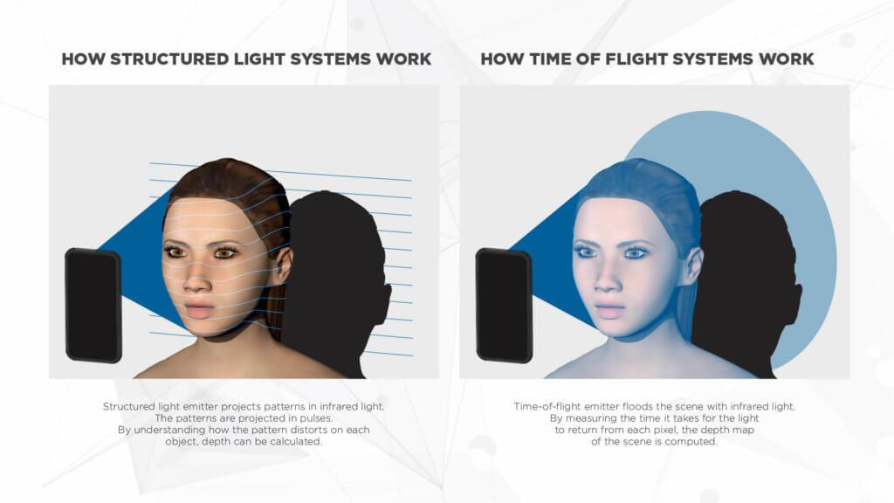
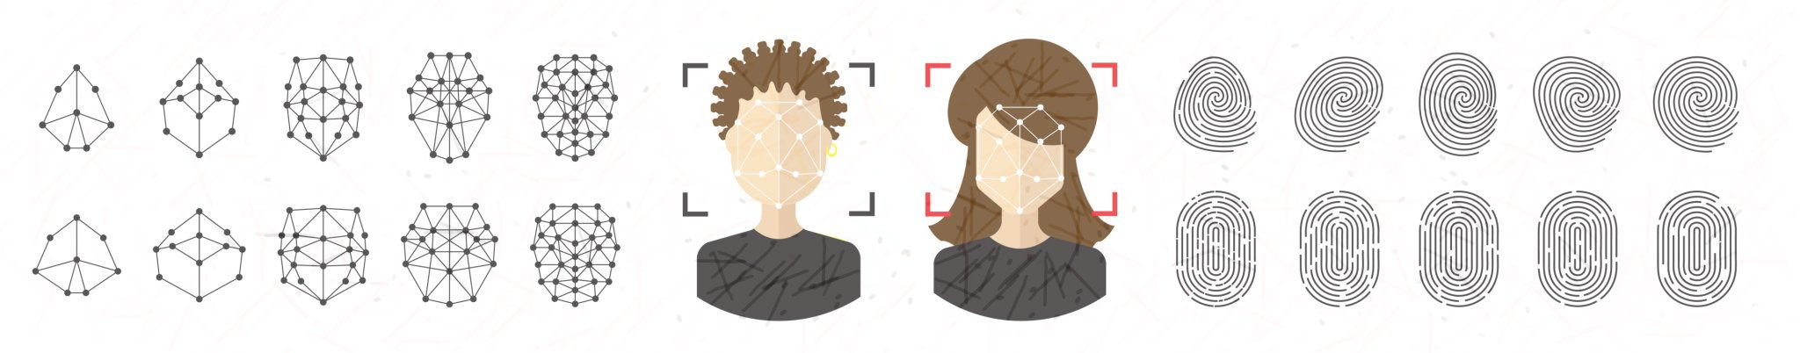
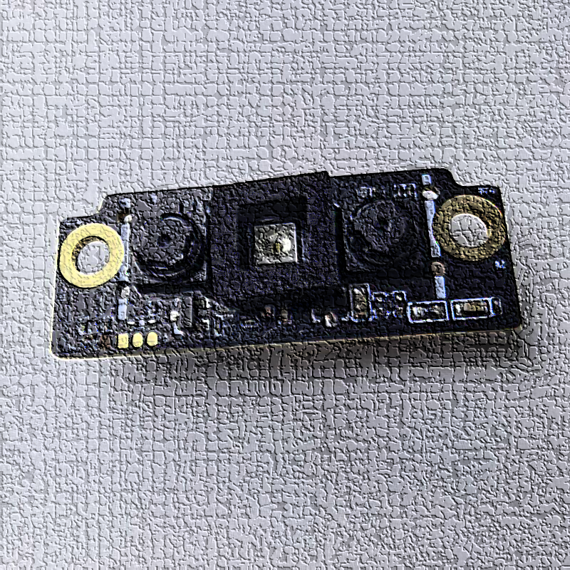
6 Key Components:
- Camera (RGB Camera)
  - Captures facial image
- Infrared (IR) Sensor
  - Works in low light
  - Detects heat patterns
- Depth Sensor (3D Mapping)
  - Creates 3D face structure
  - Improves accuracy & anti-spoofing

4. Fingerprint Recognition Sensors
Fingerprint System Components
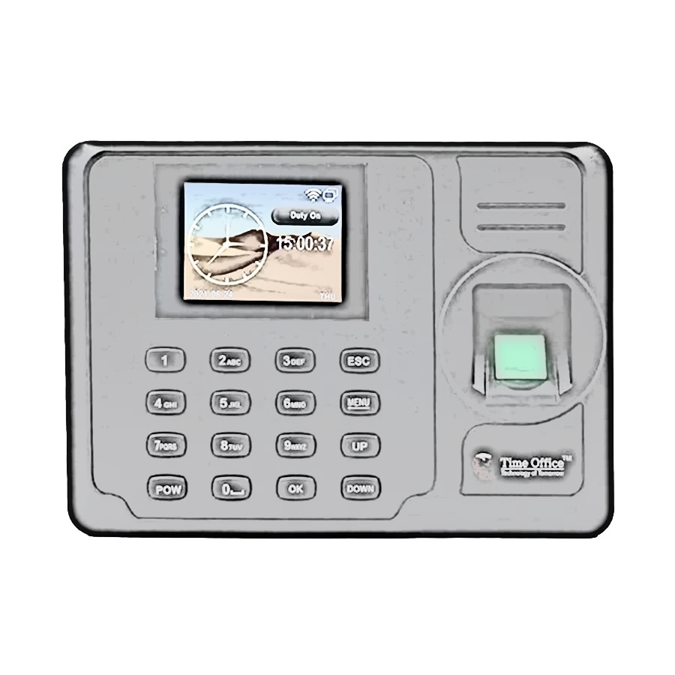

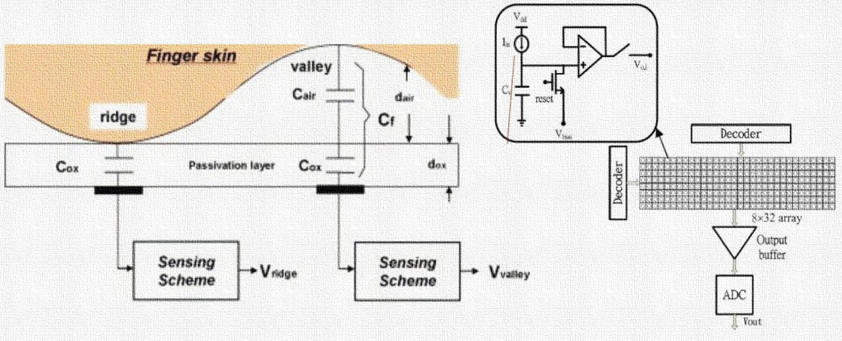
6 Types of Sensors:
- Optical Fingerprint Sensor
  - Uses light to capture fingerprint image
  - Common in attendance systems
- Capacitive Fingerprint Sensor
  - Detects electrical differences in ridges/valleys
  - More secure and accurate

5. Multi-Modal Biometric Integration
The system uses both face + fingerprint… like two guards verifying identity
How Integration Works:
- Fusion Strategy:
  - AND Logic → both face & fingerprint must match
  - OR logic (less secure) → either one works
Decision Process:
- Face matched
- Fingerprint matched
- Identity confirmed
This improves:
- Accuracy
- Security
- Resistance to spoofing

6. Data Flow in the System
Detailed Flow:
- Acquisition
  - Capture face & fingerprint
- Feature Extraction
  - Face → key points (eyes, nose, shape)
  - Fingerprint → minutiae (ridge endings, bifurcations)
- Template Creation
  - Convert features into digital vectors
- Matching
  - Compare with stored database
- Storage
  - Store encrypted biometric templates

7. Networking, Protocols & Backend
Connectivity:
- Wi-Fi / Ethernet
- Sometimes Bluetooth
Protocols Used:
- HTTP/HTTPS → communication with server
- MQTT → lightweight IoT communication
- TCP/IP → base communication
Backend/Cloud:
- Central database stores attendance
- Cloud enables:
  - Remote monitoring
  - Data analytics
  - Multi-location synchronization

8. Key Considerations
1. Accuracy
- Multi-modal improves recognition rate
- Reduces false acceptance/rejection

2. Latency
- Fast processing needed for real-time use
- Edge computing reduces delay

3. Spoofing Resistance
- IR & depth sensors prevent photo attacks
- Fingerprint sensors detect live tissue

4. Security & Privacy
- Data encryption
- Secure storage (templates, not raw images)
- Access control mechanisms
- Compliance with privacy regulations

9. Conclusion
The biometric attendance system at Shruti Building is an IoT-enabled intelligent system that integrates:
- Advanced hardware (camera + fingerprint sensors)
- Intelligent processing (feature extraction & matching)
- Secure networking and cloud systems
By using multi-modal biometrics, it achieves:
- High accuracy
- Strong security
- Reliable attendance tracking
ASSIGNMENT 4 : "Understand the Android UNO R3 pinouts and explain them."

1. Introduction
The Arduino UNO R3 is a widely used microcontroller board based on the ATmega328P.
It is used in IoT, robotics, and embedded systems for controlling sensors and devices.
Understanding its pinout and documentation helps developers use it effectively.

2. Understanding Key Terms (Arduino Perspective)
1. Pinout (PDF)
- A pinout diagram shows all pins of the Arduino board and their functions.
- It includes:
  - Digital pins
  - Analog pins
  - Power pins
  - Communication pins
It is the most important reference for connecting components.

2. Datasheet
- A datasheet provides detailed technical information about the microcontroller (ATmega328P).
- Includes:
  - Electrical characteristics
  - Voltage limits
  - Timing diagrams
  - Internal architecture
Used for deep technical understanding.

3. Schematics
- A schematic diagram shows how components on the board are connected internally.
- Includes:
  - Circuits
  - IC connections
  - Power routing
Helps in hardware troubleshooting and design.

4. CAD Files
- CAD (Computer-Aided Design) files show the physical layout of the board.
- Used for:
  - PCB design
  - 3D modeling
Useful for custom hardware development.

3. Arduino UNO R3 Pinout (Detailed Explanation)
Arduino UNO R3 Pin Layout
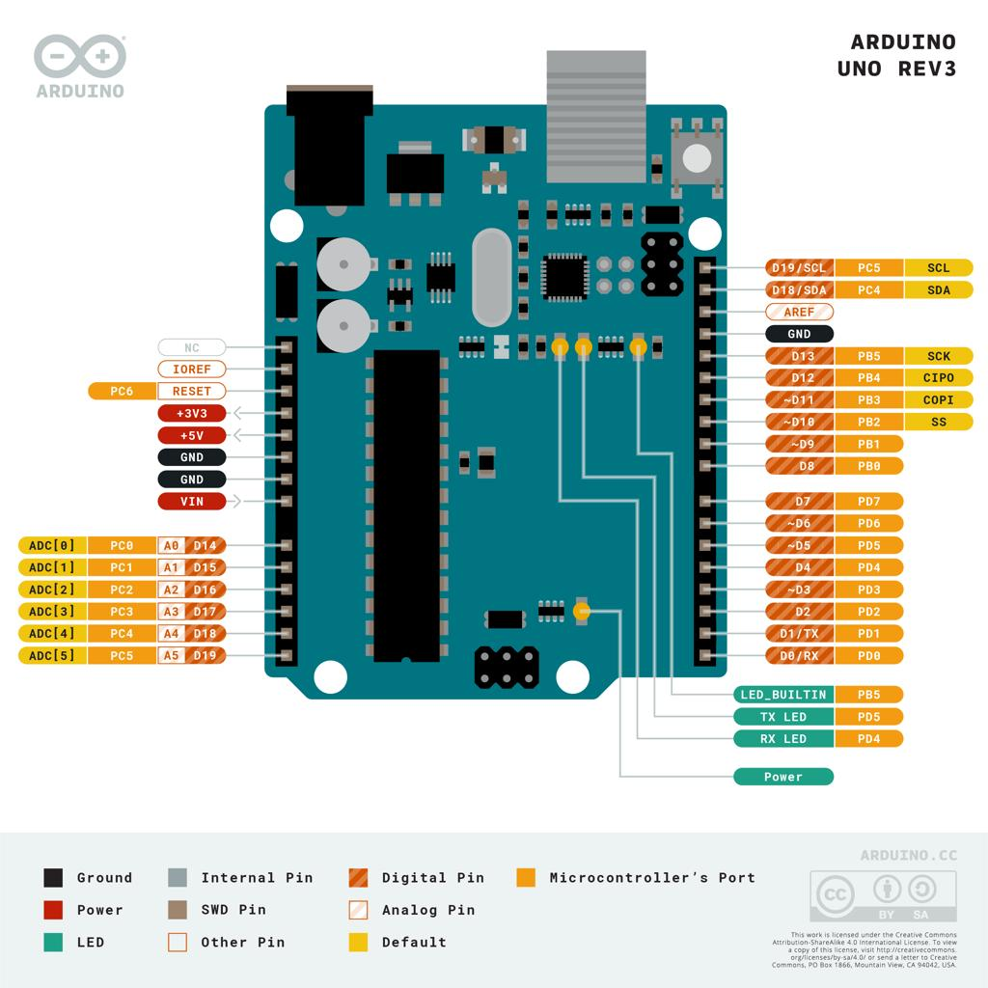
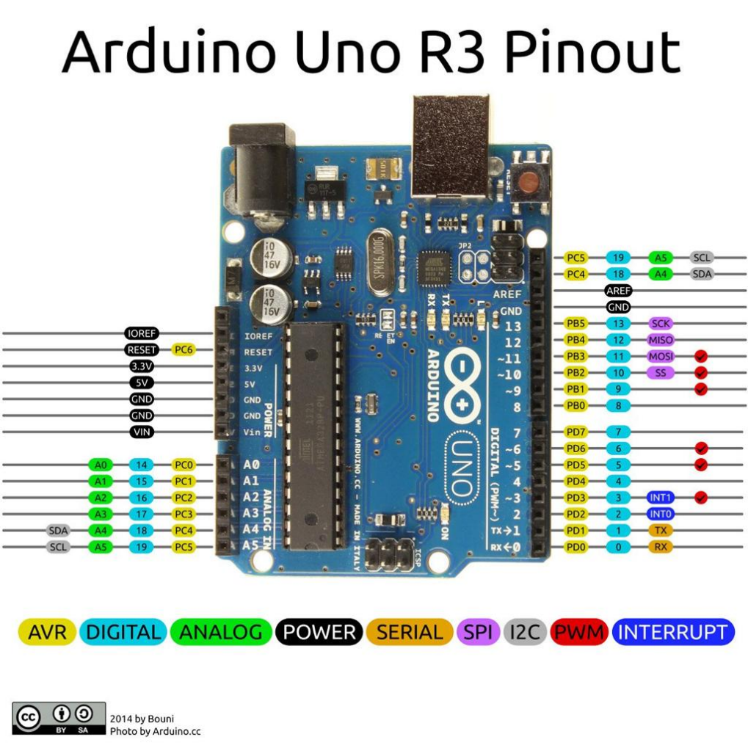
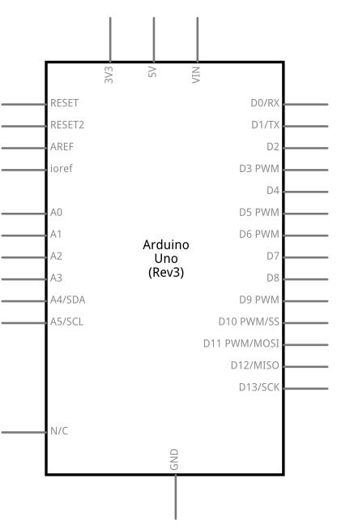
6

1. Digital Pins (0–13)
- Used for digital input/output
- Can be HIGH or LOW
Special Digital Pins:
- PWM Pins (~3, 5, 6, 9, 10, 11) → simulate analog output
- Pin 0 (RX) & 1 (TX) → serial communication

2. Analog Pins (A0–A5)
- Read analog signals (0–5V)
- Convert to digital values using ADC
Example: temperature sensor, light sensor

3. Power Pins
- 5V → power output
- 3.3V → low voltage devices
- GND → ground
- VIN → external power input

4. Communication Pins
- UART → Pins 0 (RX), 1 (TX)
- I2C → A4 (SDA), A5 (SCL)
- SPI → Pins 10 (SS), 11 (MOSI), 12 (MISO), 13 (SCK)

5. Other Important Pins
- AREF → analog reference voltage
- RESET → resets the board

4. Features of Arduino UNO R3
- Microcontroller: ATmega328P
- Operating Voltage: 5V
- Digital I/O Pins: 14
- Analog Inputs: 6
- Flash Memory: 32 KB
- Clock Speed: 16 MHz

5. Tutorials (Learning Support)
Common beginner tutorials include:
- LED blinking
- Button input
- Sensor interfacing
- Serial communication

6. Technical Specifications
- Input Voltage: 7–12V recommended
- Current per I/O pin: 20 mA
- EEPROM: 1 KB
- SRAM: 2 KB

7. Compatibility
- Compatible with:
  - Arduino IDE
  - Shields (WiFi, Bluetooth, Motor Driver)
  - Sensors and modules
Widely supported in IoT projects

8. Suggested Libraries
Some commonly used Arduino libraries:
- Servo.h → control servo motors
- Wire.h → I2C communication
- SPI.h → SPI communication
- LiquidCrystal.h → LCD display

9. Conclusion
The Arduino UNO R3 pinout provides a clear map of how to interact with the board.
Understanding pin functions, along with documentation like datasheets and schematics, helps in building efficient and reliable projects.

_______________________________________________________

ASSIGNMENT 5: Arduino enables interaction with real-world systems through Digital Pins, Analog Pins, and PWM-enabled Pins. Provide a detailed analytical discussion explaining how these three categories of pins collectively support sensing, decision-making, and control in embedded and IoT systems.

1. Introduction
The Arduino UNO interacts with the physical world using three main types of pins:
- Digital Pins
- Analog Pins
- PWM (Pulse Width Modulation) Pins
Together, they form a complete cycle of:
Sensing → Decision-Making → Control

2. Analog Pins: Sensing the Real World
Role: Input (Sensing Continuous Data)
Analog pins (A0–A5) read signals that vary continuously, such as:
- Temperature
- Light intensity
- Sound
- Gas levels
How It Works:
- Input voltage (0–5V) is converted into digital values (0–1023) using ADC (Analog-to-Digital Converter)
Example:
- LDR detects light → Analog pin reads value → Arduino understands brightness
Importance:
- Enables real-world sensing
- Captures environmental variations with precision

3. Digital Pins: Decision-Making & Logic
Role: Processing & Logical Control
Digital pins operate in two states:
- HIGH (1)
- LOW (0)
Functions:
- Read input (e.g., button pressed or not)
- Send output (turn LED ON/OFF)
Decision-Making:
Arduino uses digital logic like:
if (sensorValue > threshold) {
digitalWrite(LED, HIGH);
}
Example:
- Motion detected → digital input HIGH → alarm activated
Importance:
- Acts as the decision-making bridge
- Converts sensed data into logical actions

4. PWM Pins: Control & Actuation
Role: Output (Analog-like Control)
PWM pins (~3, 5, 6, 9, 10, 11) simulate analog output using digital signals.
How It Works:
- Rapid ON/OFF switching
- Controls duty cycle (percentage of ON time)
$$\text{Duty Cycle}=\frac{T_{on}}{T_{total}}×100\%$$
Example:
- 50% duty cycle → medium LED brightness
- 100% → full brightness
Applications:
- Motor speed control
- LED dimming
- Fan regulation

5. Integrated Working: The Complete IoT Cycle

Full System Flow
1. Sensing (Analog Pins)
- Sensor collects real-world data
- Example: Temperature = 35°C

2. Decision-Making (Digital Logic)
- Arduino processes data
- Compares with threshold

3. Control (PWM/Digital Output)
- Adjusts output:
  - Turn ON fan
  - Increase motor speed

Example: Smart Fan System
Step | Action
Sensing | Temperature sensor reads heat
Decision | If temp > 30°C
Control | PWM increases fan speed

6. Role in IoT Systems
In IoT environments, these pins enable:
Connectivity + Intelligence
- Sensors collect data → Analog pins
- Microcontroller processes → Digital logic
- Actuators respond → PWM/Digital output
Example:
- Smart home system
- Industrial automation
- Health monitoring

7. Analytical Insight
Each pin type alone is incomplete… but together:
- Analog Pins → perception
- Digital Pins → reasoning
- PWM Pins → action
This combination transforms Arduino into an:
Intelligent edge device capable of real-time interaction

8. Conclusion
Digital, Analog, and PWM pins collectively create a complete embedded system loop:
- Sense environment
- Process information
- Control outputs
This integration is fundamental to embedded systems and IoT applications, enabling automation, efficiency, and intelligent decision-making.
______________________________________________________________________

ASSSIGNMENT 6: Analyze the different communication mechanisms used in embedded systems by comparing serial and parallel communication, analog and digital communication, and synchronous and asynchronous protocols. Discuss how these categories differ in terms of data transmission, efficiency, complexity, and reliability, and evaluate their role in enabling effective interfacing between microcontrollers and external devices in real-world applications.

1. Introduction
Communication in embedded systems allows microcontrollers to interact with:
- Sensors
- Actuators
- Other devices
Different mechanisms are used depending on speed, distance, complexity, and reliability.
This analysis compares:
- Serial vs Parallel
- Analog vs Digital
- Synchronous vs Asynchronous

2. Serial vs Parallel Communication
Basic Concept
Type | Description
Serial | Data sent one bit at a time
Parallel | Multiple bits sent simultaneously

Comparison
Factor | Serial Communication | Parallel Communication
Data Transmission | 1 bit at a time | Multiple bits (8/16) at once
Speed | Slower per cycle, but efficient over distance | Faster for short distances
Wiring | Few wires | Many wires
Complexity | Simple | Complex
Reliability | High (less interference) | Lower (crosstalk issues)

Analysis
- Serial is widely used in modern systems (UART, SPI, I2C)
- Parallel is used where high-speed short-distance transfer is needed (e.g., internal buses)
In IoT systems, serial communication dominates due to simplicity and reliability.

3. Analog vs Digital Communication
Basic Concept
Type | Description
Analog | Continuous signal (voltage varies smoothly)
Digital | Discrete signals (0s and 1s)

Comparison
Factor | Analog | Digital
Signal Type | Continuous | Discrete
Noise Sensitivity | High | Low
Accuracy | Lower | Higher
Processing | Complex | Easier
Reliability | Less reliable | More reliable

Analysis
- Analog is used in sensor data collection (temperature, sound)
- Digital is used in processing and communication
Embedded systems often convert:
Analog → Digital (ADC)
This allows accurate processing and transmission.

4. Synchronous vs Asynchronous Communication
Basic Concept
Type | Description
Synchronous | Uses a shared clock signal
Asynchronous | No clock, uses start/stop bits

Comparison
Factor | Synchronous | Asynchronous
Timing | Clock-based | No clock
Speed | Faster | Slower
Complexity | More complex | Simpler
Efficiency | High (no extra bits) | Lower (start/stop overhead)
Examples | SPI, I2C | UART

Analysis
- Synchronous → high-speed, precise communication
- Asynchronous → simple, flexible communication
Choice depends on:
- Required speed
- System complexity

5. Overall Comparative Insight
How They Fit Together
These categories are not isolated… they overlap:
- Serial communication can be:
  - Synchronous (SPI)
  - Asynchronous (UART)
- Data can be:
  - Analog (sensor input)
  - Converted to digital (for processing)

6. Role in Real-World Embedded Systems
Practical Applications
IoT Devices
- Serial (I2C, SPI) connects sensors
- Digital communication ensures reliability

Automotive Systems
- Parallel used in internal processing
- Serial used for communication (CAN, LIN)

Healthcare Devices
- Analog signals from sensors
- Digital processing for accuracy

Smart Home Systems
- Asynchronous UART for simple modules
- Synchronous SPI for fast data transfer

7. Evaluation
Efficiency
- Serial + synchronous → most efficient for modern systems
Complexity
- Parallel + synchronous → highest complexity
Reliability
- Digital + serial → most reliable

8. Conclusion
Different communication mechanisms serve different purposes:
- Serial vs Parallel → trade-off between wiring and speed
- Analog vs Digital → sensing vs processing
- Synchronous vs Asynchronous → speed vs simplicity
Together, they enable:
Effective interfacing between microcontrollers and external devices
This layered communication approach is essential for building efficient, reliable, and scalable embedded and IoT systems.

ASSIGNMENT: 7
List major MQTT client libraries across different programming languages,and list major MQTT broker implementations available in the market, compare their features.

Major MQTT Client Libraries Across Programming Languages
Programming Language | MQTT Client Library | Key Features
C | Eclipse Paho C | Lightweight, MQTT 3.1.1/5.0 support, embedded systems
C/C++ | wolfMQTT | TLS support, embedded IoT devices, RTOS compatible
C++ | Boost.MQTT5 | Modern C++20 support, async communication
Java | HiveMQ MQTT Java Client | High-performance, MQTT 5 support, reactive APIs
Java | Eclipse Paho Java Client | Widely used, stable, cross-platform
Python | Paho-MQTT | Easy to use, popular for IoT prototyping
JavaScript / Node.js | MQTT.js | Browser and Node.js support using WebSockets
Go | Paho MQTT Go Client | Concurrency support, lightweight
C# / .NET | MQTTnet | MQTT broker + client, async APIs
Kotlin | KMQTT | Kotlin-native implementation
Rust | rust-mqtt | Embedded-ready, MQTT v5 support
Embedded Systems | Eclipse Paho Embedded C | Optimized for microcontrollers
These libraries support MQTT publish/subscribe communication for IoT systems and vary in performance, scalability, and embedded-device compatibility.

Major MQTT Broker Implementations
MQTT Broker | Programming Language | Open Source | Main Features
Mosquitto | C | Yes | Lightweight, low memory usage, MQTT 5 support
EMQX | Erlang | Yes | Massive scalability, clustering, high availability
HiveMQ | Java | Community + Enterprise | Enterprise-grade, cloud-native, MQTT 5
RabbitMQ | Erlang | Yes | Multi-protocol support including MQTT
VerneMQ | Erlang | Yes | Distributed clustering, fault tolerance
NanoMQ | C | Yes | Edge computing optimized
Moquette | Java | Yes | Lightweight Java broker
Aedes | JavaScript | Yes | Broker for Node.js applications
Mongoose | C/C++ | Yes | Embedded networking and MQTT support
CoreFlux | C | Commercial | Industrial IoT focus

Comparison of MQTT Brokers
Feature | Mosquitto | EMQX | HiveMQ | RabbitMQ | VerneMQ
MQTT 5 Support | Yes | Yes | Yes | Partial/Plugin | Yes
Scalability | Medium | Very High | Very High | High | High
Clustering | Limited | Advanced | Advanced | Advanced | Advanced
Lightweight | Excellent | Moderate | Moderate | Heavy | Moderate
Enterprise Features | Basic | Extensive | Extensive | Extensive | Moderate
Cloud Integration | Limited | Strong | Strong | Strong | Moderate
Best Use Case | Small IoT projects | Large-scale IoT | Enterprise IoT | Multi-protocol messaging | Distributed IoT
Programming Language | C | Erlang | Java | Erlang | Erlang

Summary
- Mosquitto is best for lightweight and small IoT deployments.
- EMQX is highly scalable and suitable for millions of IoT connections.
- HiveMQ is enterprise-focused with strong cloud and analytics integration.
- RabbitMQ is useful when multiple messaging protocols are needed.
- VerneMQ is optimized for distributed and fault-tolerant IoT systems.
MQTT client libraries and brokers together form the communication backbone of modern IoT systems by enabling efficient publish/subscribe messaging between edge devices, gateways, and cloud platforms.

